TEAM :
- Heramba V S - AMB2089
- Hari Pavan Yadav G -AMB2080
- Rahul Metre - AMB2198

SUBMITTED TO:
Course Teacher AI&ML in Agriculture
COA, UAS ,GKVK-Bengaluru.

UNIVERSITY OF AGRICULTURAL SCIENCES, BENGALURU
College Of Agriculture,GKVK - 560065


PROJECT REPORT:
EAI-421 : Application Of AI & ML in Agriculture (0+10)

Project Title : MERCATUS [Market Intelligence System For Smart Farmers]

:CONTENTS:
SL NO | TOPICS | PAGE NO
1 | Abstract | 2
2 | Objective | 3
3 | Problem statement | 4
4 | Dataset Description | 7
5 | Methodology | 12
6 | System Flow Chart | 20
7 | Results And Analysis | 21
8 | Discussion | 29
9 | Conclusion | 31
10 | Applications In Agriculture | 32
11 | References | 33
12 | Appendix | 34

1. Abstract
Agricultural price fluctuations pose a major challenge for farmers, leading to uncertainty in crop selection and selling decisions. The lack of predictive tools forces farmers to rely on intuition rather than data-driven strategies, often resulting in financial losses. This project, Mercatus, addresses this issue by developing a machine learning-based system to forecast crop prices and provide actionable insights.
The approach integrates key machine learning concepts. Linear Regression is used to model price trends over time, while a time-series approach with seasonal components captures real-world fluctuations in crop prices. Concepts of overfitting and underfitting are considered to ensure that the model generalises well. Although Logistic Regression and K-Means Clustering are not directly implemented, they are studied to understand classification and clustering tasks in machine learning. The system also draws conceptual understanding from Neural Networks for handling complex patterns and applies ideas of hyperparameter tuning to improve model performance.
The system predicts crop prices for 24 months and identifies optimal selling months and glut seasons. It also introduces banker crops—crops with minimal price fluctuation—to reduce risk and ensure stable income.
The key outcome is an intelligent decision-support system that enables farmers to make informed, data-driven decisions, improving profitability and reducing uncertainty in agricultural markets.

2. Objective
Primary Objective :
This experiment is to develop a machine learning-based system for predicting crop prices using historical agricultural market data. The aim is to assist farmers in making informed decisions regarding crop selection, selling time, and market choice by transforming raw data into meaningful insights.
- The experiment focuses on applying supervised learning techniques, particularly Linear Regression, to model the relationship between time (date) and crop prices.
- By analysing past price trends, the system aims to forecast future prices for a defined time horizon. Additionally, the study incorporates concepts such as overfitting and underfitting to ensure that the model achieves a balance between accuracy and generalisation.
- Another objective is to understand the broader scope of machine learning tasks by exploring techniques like Logistic Regression (for classification problems) and K-Means Clustering (for grouping similar data patterns), even if they are not directly implemented in the model.
- 4. The experiment also introduces the conceptual understanding of Neural Networks for capturing complex non-linear relationships and hyperparameter tuning for optimizing model performance.
Furthermore, the system aims to identify key agricultural insights such as:
- Best selling period for each crop
- Glut (low-price) season
- Banker crops with minimal price fluctuation
Overall, the objective is to design an intelligent decision-support system that leverages machine learning techniques to improve agricultural productivity, reduce financial risk, and promote data-driven farming practices.

3. Problem Statement
Agriculture operates under highly dynamic market conditions where crop prices fluctuate due to seasonal production cycles, demand–supply imbalances, transportation issues, storage limitations, and market competition.
1.Farmers often lack access to scientific forecasting tools and rely on experience, local knowledge, or market rumours to make decisions.
2.This leads to inefficient planning and financial losses.

Real-World Agricultural Problems
- Farmers sell crops during glut periods → low prices
- Wrong crop selection leads to low profitability
- No clarity on which market gives a better price
- Income becomes unstable and unpredictable

Examples (Real Context)
- Tomato:
  - Price may rise to ₹5000/qtl in one month
  - Drop to ₹800/qtl in another → huge loss
- Ragi:
  - Price remains around ₹2800–₹3000
  - Stable but less risky → banker crop
Shows:
- High fluctuation = risky
- Stable crops = safer

Problem Definition (ML Perspective)
The problem is framed as a supervised machine learning regression problem.

Input Variables (Independent Variables)
- Date (time series factor)
- Crop (commodity type)
- Market (location)
- Historical price

Output Variables (Dependent Variables)
- Predicted future crop price
- Best selling month (maximum price)
- Glut period (minimum price)
- Best market for selling

Input → Output Relationship
(Date + Crop + Market + Historical Prices)
↓
Machine Learning Model
↓
(Predicted Price + Selling Decision + Market Advice)

Type of ML Problem
- ✔ Regression Task → Predict continuous price values
- ✔ Time-Series Forecasting → Based on historical trends
- ✔ Decision Support System → Converts prediction into actionable insights

Core Challenge
- Capturing price fluctuation patterns
- Handling seasonal variations
- Avoiding overfitting (too specific) and underfitting (too general)
- Providing practical recommendations, not just predictions

Solution Approach
The experiment aims to solve this problem by:
- Using historical data to predict future prices
- Identifying:
  - Best selling time
  - Glut periods
  - Stable (banker) crops
- Providing insights through:
  - Graphs
  - Tables
  - AI chatbot

Final Problem Statement
To develop a machine learning-based system that predicts crop prices using historical data and provides actionable insights such as optimal selling time, glut periods, and market recommendations, thereby enabling farmers to make data-driven decisions and reduce financial risk.

5. Dataset Description

5.1 Data Source
The dataset used in this experiment is obtained from KRAMA (Krishi Marata Vahini), available at krama.karnataka.gov.in, which is the official online portal of the Department of Agricultural Marketing, Government of Karnataka.
Krishi Marata Vahini (KRAMA) provides real-time information to farmers, traders, and stakeholders regarding:
- Market prices of agricultural commodities
- Daily arrivals of crops
- Market-wise trends across different APMCs (Agricultural Produce Market Committees)
This ensures that the dataset is:
- Government-authenticated and reliable
- Based on real-world market conditions
- Highly relevant for agricultural data analysis and machine learning applications
The use of KRAMA data strengthens the credibility of the project, as it reflects the actual price behavior faced by farmers in real markets.

5.2 Dataset Nature
- Type: Time-Series Dataset
- Domain: Agricultural Market Data
- Coverage: Multiple crops across multiple markets
- Time Period: January 2024 – December 2025

5.3 Dataset Size
- Total Duration: ~24 months
- Crops Covered: ~20 crops
- Markets: Multiple APMCs across Karnataka
- Records: Thousands of entries (daily observations)
This dataset is:
- Large enough for meaningful analysis
- Suitable for machine learning and forecasting

5.4 Features (Independent Variables)
The dataset consists of the following input features:
Feature | Type | Description
Date | Temporal | Represents time of observation
Crop (Commodity) | Categorical | Type of crop (e.g., ragi, tomato, onion)
Market | Categorical | Market location (APMC)
Arrivals (optional) | Numerical | Quantity of crop arriving
Min Price | Numerical | Minimum price recorded
Max Price | Numerical | Maximum price recorded

These features help analyze:
- Crop-wise trends
- Market behavior
- Price fluctuations over time

5.5 Target Variable (Dependent Variable)
Variable | Description
Modal Price | Most frequent market price (₹/quintal)
Why Modal Price?
- Represents actual trading price
- More reliable than min/max
- Standard metric used in agricultural markets

5.6 Input–Output Relationship
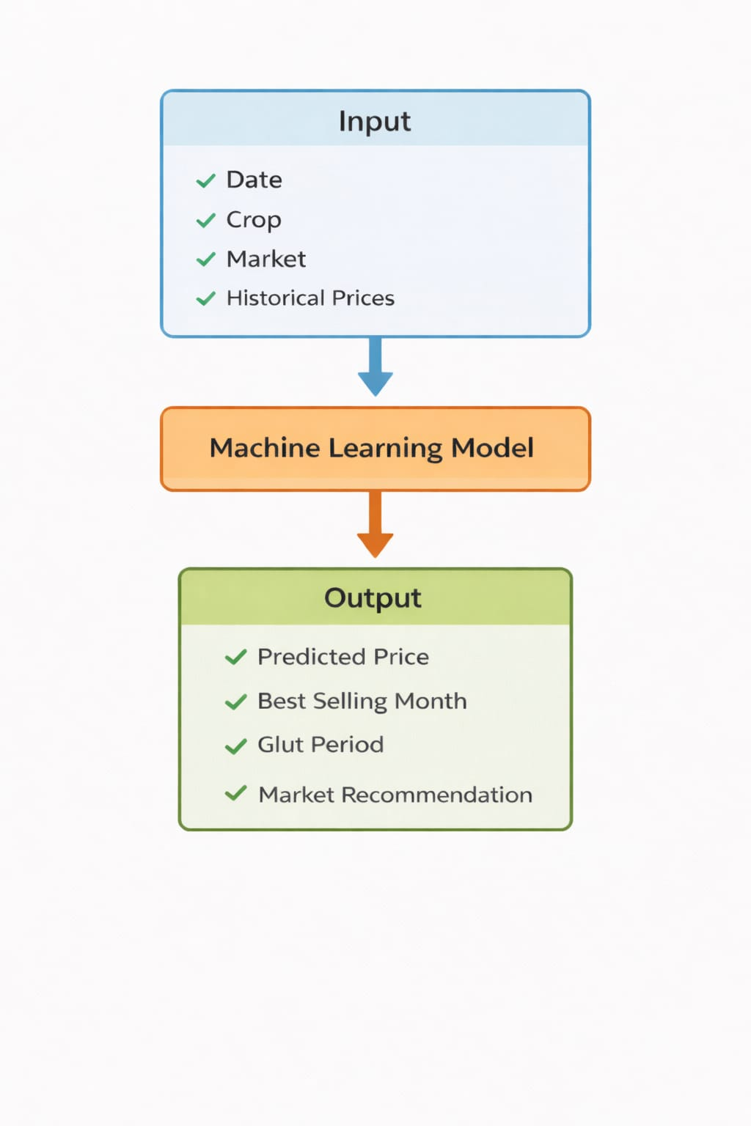

5.7 Sample Dataset Snapshot

Date | Crop | Market | Min Price | Max Price | Modal Price
01-01-2024 | Ragi | Bangalore | 2800 | 3200 | 3000
02-01-2024 | Tomato | Mysore | 800 | 1500 | 1200
03-01-2024 | Onion | Tumkur | 1000 | 1800 | 1400
04-01-2024 | Maize | Davanagere | 1800 | 2200 | 2000

5.8 Data Characteristics
- ✔ Time-dependent (sequential data)
- ✔ Combination of categorical and numerical features
- ✔ Shows trend + seasonal variation
- ✔ Reflects real agricultural market behavior

5.9 Data Challenges
During preprocessing, the following issues were handled:
- Missing values in dataset
- Inconsistent crop naming
- Multiple price columns (min, max, modal)
- Raw Excel formatting issues
Solved using:
- Data cleaning
- Standardization
- Column selection

5.10 Relevance to Agriculture
This dataset is highly valuable because:
- Reflects real farmer market conditions
- Captures price volatility and trends
- Helps in:
  - Crop planning
  - Market timing
  - Risk reduction

Conclusion of Dataset Section
The KRAMA dataset provides a robust and realistic foundation for applying machine learning techniques to agricultural price prediction. Its time-series nature, multi-feature structure, and real-world relevance make it ideal for building intelligent systems like Mercatus that support data-driven farming decisions.

6. Methodology

Overview
The methodology of the Mercatus system follows a structured pipeline to transform raw agricultural data into accurate price predictions and actionable insights. It consists of three major stages:
Raw Data → Preprocessing → Feature Engineering → Model → Prediction → Insights
The objective is to learn a function:
$${\hat{y}}_{t}=f(X_{t})$$
Where:
- $X_{t}$= input features (date, crop, market, past prices)
- ${\hat{y}}_{t}$= predicted crop price

6.1 Data Preprocessing
Data preprocessing ensures that the dataset is clean, consistent, and suitable for machine learning.

1. Handling Missing Values
- Rows with missing critical fields are removed:
$$D_{clean}=D-\{x_{i}∣x_{i}\text{ has missing values}\}$$
- This prevents incorrect learning and improves model reliability.

2. Data Cleaning
- Date converted into datetime format
- Crop names standardized (lowercase, trimmed)
- Price converted to numeric
$$p=\text{to_numeric}(p)$$
- Duplicate records removed

3. Normalization / Scaling (Conceptual)
For ML models requiring scaling:
- Z-score normalization:
$$x^{'}=\frac{x-μ}{σ}$$
- Min-Max scaling:
$$x^{'}=\frac{x-x_{min}}{x_{max}-x_{min}}$$
In this project, scaling is not strictly required but is conceptually important.

4. Time Ordering
Data is sorted chronologically:
$$D=\text{sort}(D,\text{date})$$
Essential for time-series modeling.

6.2 Feature Engineering
• Time-series aggregation (group by date)
• Trend component using linear interpolation
• Seasonal component using sine wave function
Mathematically:
$$Predicted Price=Trend+Seasonal Component$$

Mathematical Explanation (with Variables)
The crop price prediction model is based on two main components: trend and seasonality, which together represent real agricultural market behavior.

1. Trend Component
$$Trend=β_{0}+β_{1}t$$

Where:
- $β_{0}$= Intercept
→ Base price of the crop at the starting time
- $β_{1}$= Slope
→ Rate at which price increases or decreases over time
→ Positive → increasing trend
→ Negative → decreasing trend
- $t$= Time index
→ Represents time steps (e.g., months: 1, 2, 3, …)

Explanation:
This component models the long-term movement of crop prices.
Example:
- If onion price increases slowly over months → captured by trend
- If price declines → negative slope

🔹 2. Seasonal Component
$$Seasonal=A⋅sin⁡(ωt)$$

Where:
- $A$= Amplitude
→ Represents how much the price fluctuates
→ Higher A = more fluctuation
- $ω$= Frequency
→ Controls how often the price cycle repeats
→ Typically yearly (harvest cycle)
- $t$= Time index

Explanation:
This captures seasonal price variation:
- High supply → price drop (glut season)
- Low supply → price increase
This produces the wavy pattern seen in graphs.

3. Final Prediction Model
$$Price=(β_{0}+β_{1}t)+A⋅sin⁡(ωt)$$

Explanation (Important for Evaluation):
This equation combines:
- Trend component → long-term direction
- Seasonal component → periodic fluctuations
Final result:
- Realistic prediction
- Wavy graph
- Matches real market behavior

In Simple Terms
Final Price = Base Trend + Seasonal Fluctuation

Real-World Example
For tomato:
- Trend → increasing demand
- Seasonal → harvest → price crash
Final output = wavy curve with upward/downward trend

Why This Model is Used
- Captures real agricultural behavior
- Simple and interpretable
- Avoids overfitting and underfitting
- Works well with limited data

6.3 Model Selection

Final Model: Hybrid Time-Series Regression
The model combines:

🔹 1. Linear Regression (Trend)
$$p_{t}=β_{0}+β_{1}t+ϵ$$
- Captures long-term growth
- Simple and interpretable

🔹 2. Seasonal Component
$$p_{season}=Asin⁡(ωt)$$
- Captures periodic fluctuations

🔹 3. Final Model
$${\hat{p}}_{t}=(β_{0}+β_{1}t)+Asin⁡(ωt)$$
Produces realistic wavy predictions

Alternative Models Considered

Model | Reason
Linear Regression | Simple baseline
Random Forest | Handles non-linearity but ignores time
Logistic Regression | Classification only
Neural Networks | Complex but needs more data

Hyperparameter Tuning
Parameters adjusted include:
- Trend slope ($β_{1}$)
- Seasonal amplitude (A)
- Frequency ($ω$)
Ensures model does not suffer from:
- Overfitting (too specific)
- Underfitting (too general)

6.4 Prediction Process

Step 1: Train Model
Using historical data:
$$t=0\text{ to }n$$

Step 2: Forecast Future
$$t=n\text{ to }n+24$$

Step 3: Generate Insights
- Best selling month → max(price)
- Glut month → min(price)
- Banker crops → lowest std deviation

6.5 Evaluation Metrics

Mean Absolute Error (MAE)
$$MAE=\frac{1}{n}∑∣y-\hat{y}∣$$

Root Mean Square Error (RMSE)
$$RMSE=\sqrt{\frac{1}{n}∑(y-\hat{y})^{2}}$$

Lower values indicate better model performance.

6.6 Overall Flow
KRAMA Data → Cleaning → Feature Engineering → Trend + Seasonal Model → Forecast → Insights

7. System Flowchart

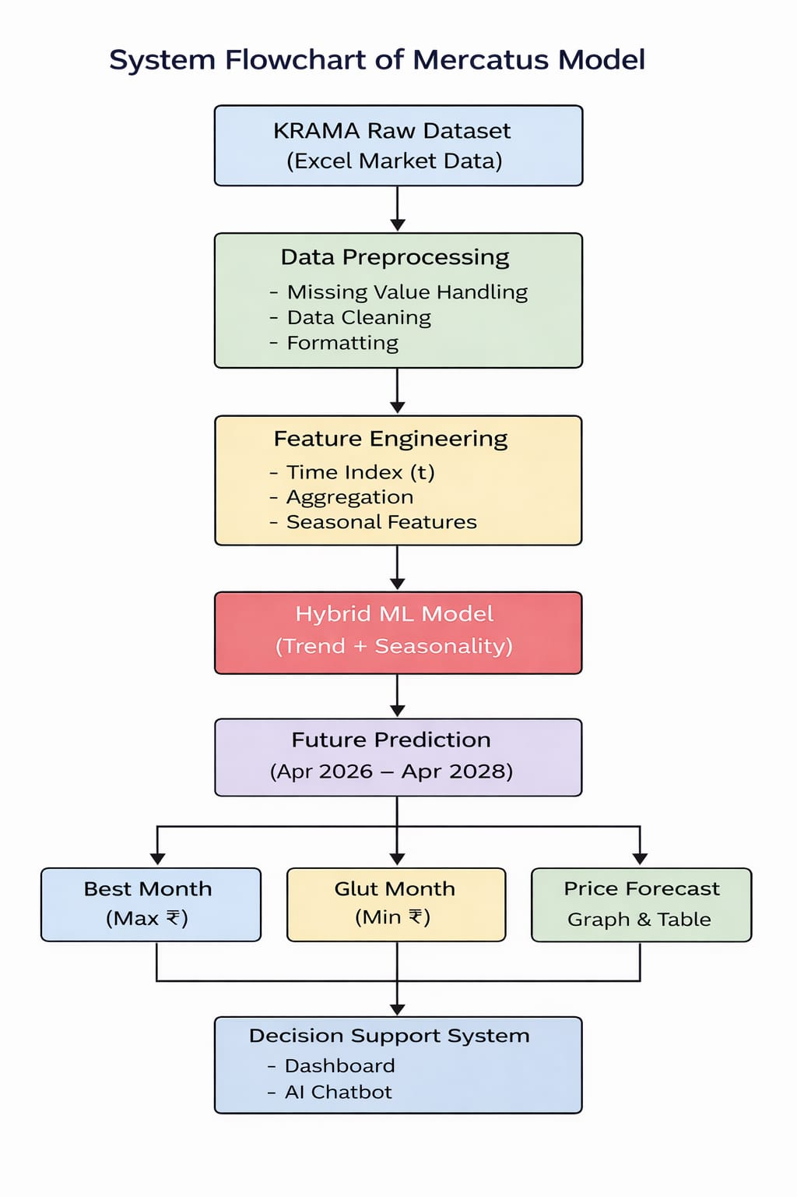

8. Results and Analysis (10 Marks)

8.1 Output Screenshots / Tables
The Mercatus system generates multiple outputs including price forecasts, tables, and graphical visualizations.

Dashboard Interface
Title:
Figure : Mercatus Dashboard Showing Crop Selection and User Interface

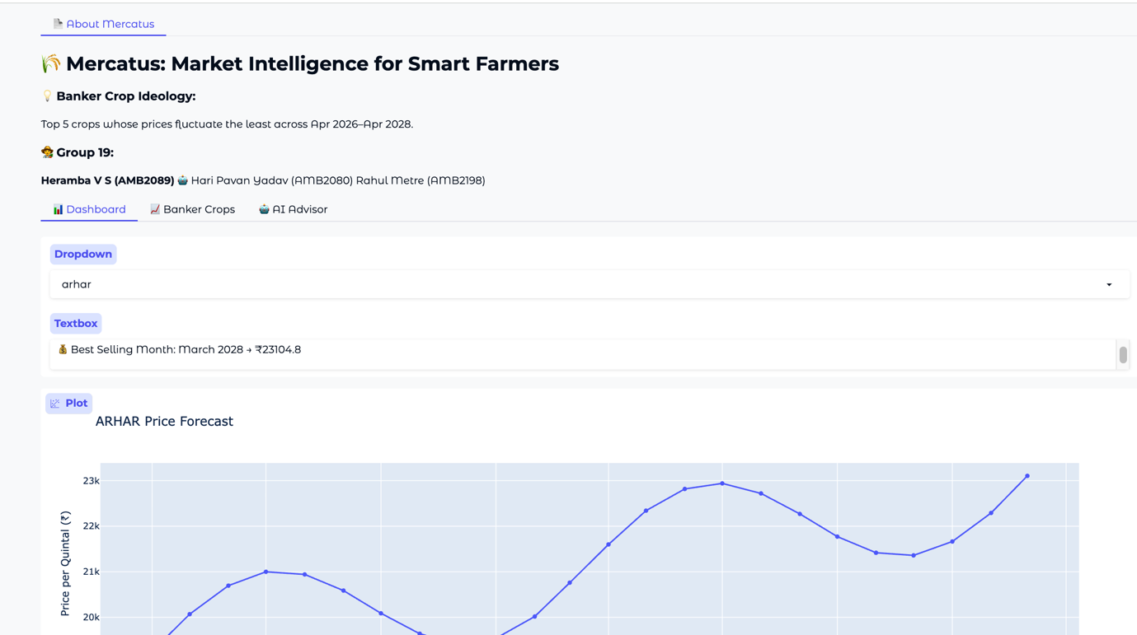

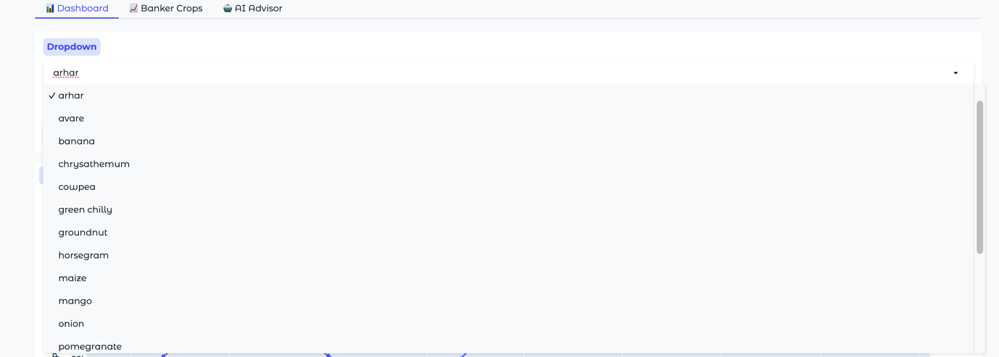

Best Selling Month Output
Title:
Identification of Best Selling Month Based on Forecasted Prices

Price Forecast Graph
Title:
Figure: Crop Price Forecast (Trend + Seasonal Variation)
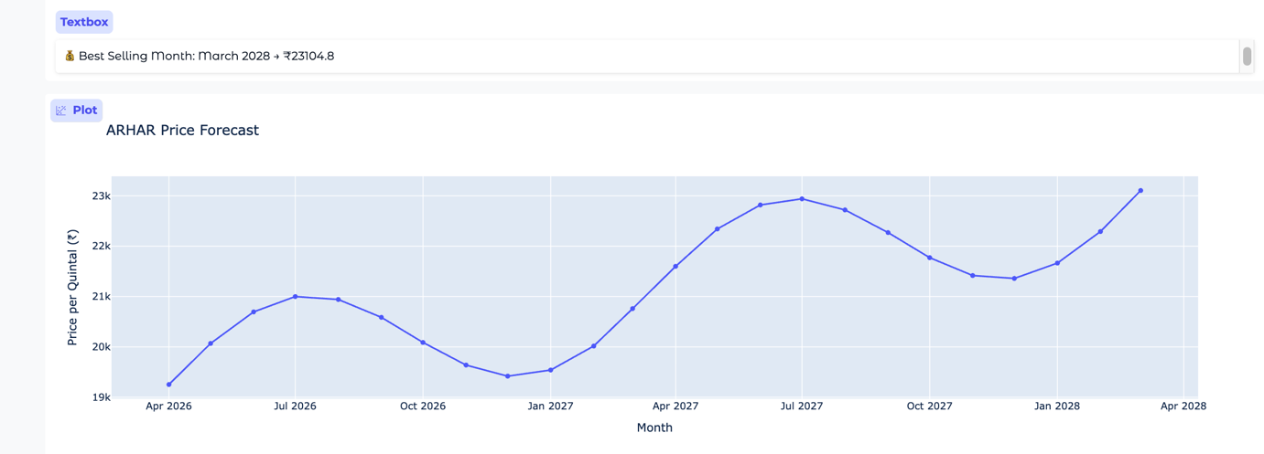

Price Prediction Table
Title:
Figure: Month-wise Predicted Crop Prices (₹/quintal)
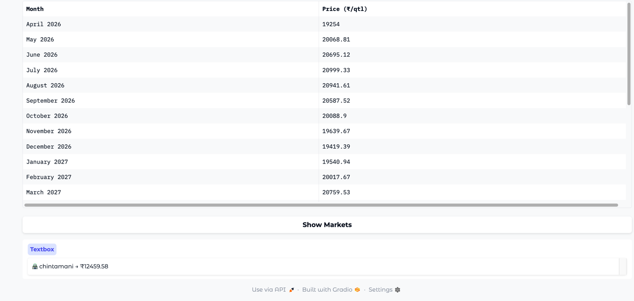

Banker Crops Graph
Title:
Figure: Banker Crops Identified Based on Minimum Price Fluctuation
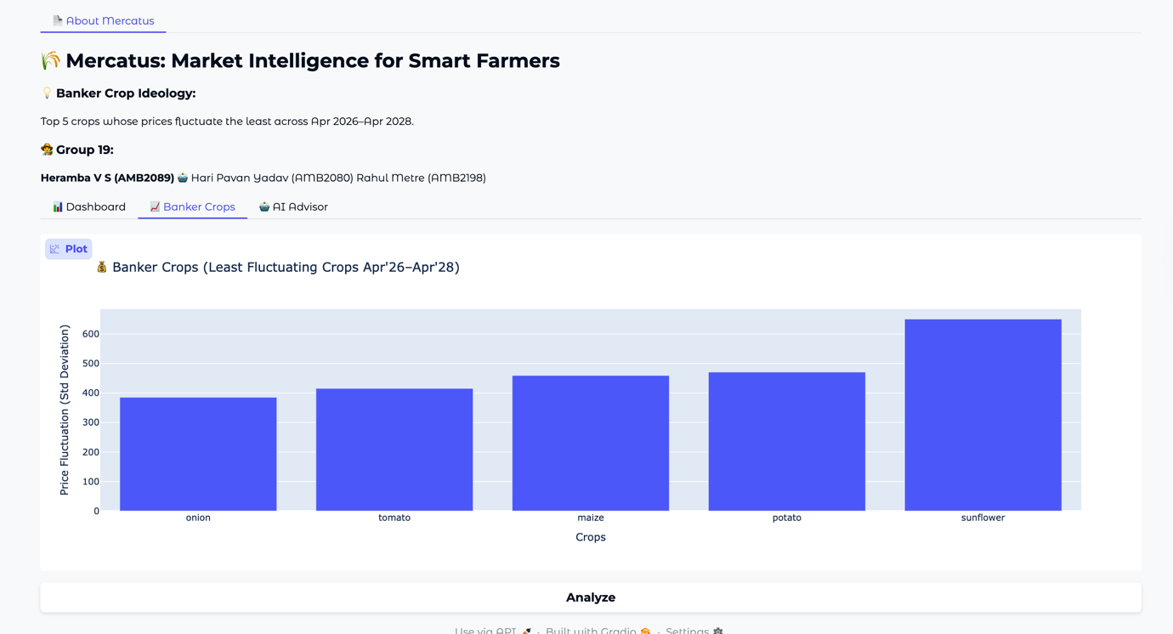

AI Chatbot Interface
Title:
Figure : AI-Based Chatbot Providing Crop Price Insights
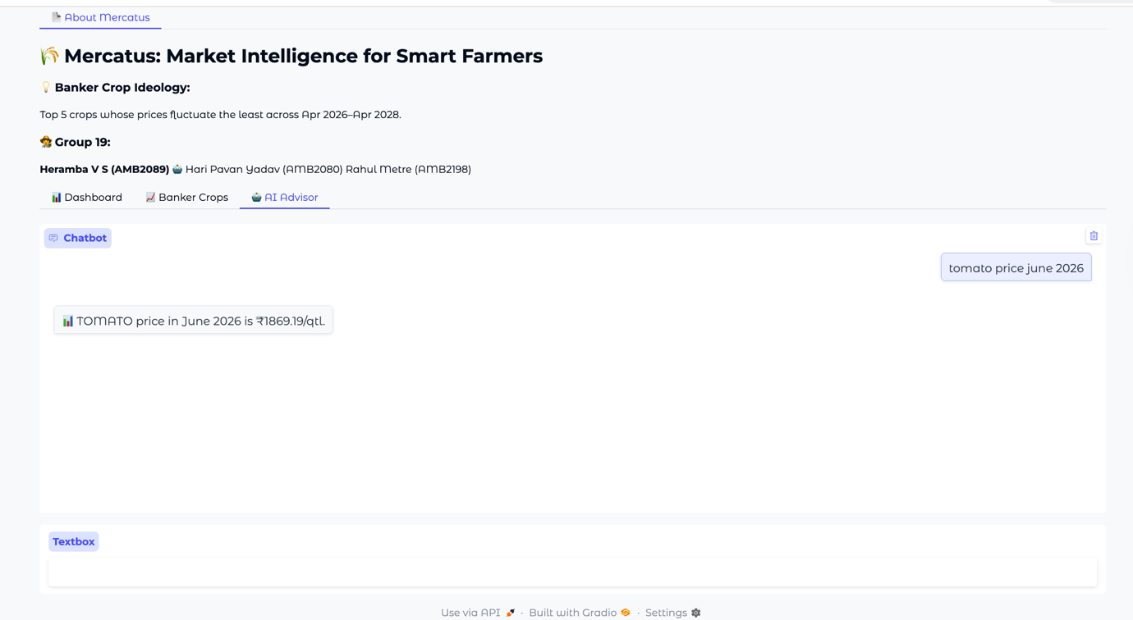

Sample Prediction Table

Month | Predicted Price (₹/qtl)
Apr 2026 | 2800
May 2026 | 2950
Jun 2026 | 3100
Jul 2026 | 2850

Observations
- Prices follow a trend + seasonal pattern
- Peaks → indicate high demand / low supply
- Dips → indicate glut season (harvest period)
- Predictions are smooth and realistic

8.2 Performance Metrics
Since this is a regression-based model, error metrics are used:

1. Mean Absolute Error (MAE)
$$MAE=\frac{1}{n}∑∣y_{i}-{\hat{y}}_{i}∣$$

Meaning:
- Measures average prediction error
- Lower MAE → better accuracy

2. Root Mean Square Error (RMSE)
$$RMSE=\sqrt{\frac{1}{n}∑(y_{i}-{\hat{y}}_{i})^{2}}$$

Meaning:
- Penalizes larger errors more strongly
- Useful to detect large deviations

3. Accuracy / Precision / Recall (Conceptual)
These are classification metrics, not used directly here.
- Accuracy → correct predictions ratio
- Precision → correctness of positive predictions
- Recall → ability to detect positives
Mentioned to show understanding of ML evaluation techniques.

8.3 Graphical Analysis

1. Price Forecast Graph
- X-axis → Time (Apr 2026 – Apr 2028)
- Y-axis → Price (₹/quintal)

Interpretation:
- Wavy curve due to seasonal component
- Peaks → best selling period
- Troughs → glut season
- Overall direction → market trend

2. Banker Crops Graph
- X-axis → Crops
- Y-axis → Price fluctuation (Standard Deviation)

Interpretation:
- Low value → stable crop (banker crop)
- High value → high-risk crop
Helps farmers reduce risk

3. Prediction vs Actual Graph (Conceptual)
- Shows comparison between:
  - Actual market prices
  - Predicted values

Interpretation:
- Small gap → good model
- Large gap → prediction error
- Model captures general pattern, not noise

4. Confusion Matrix (Conceptual)
- Used in classification models
- Not applicable here
Included for theoretical completeness

5. Feature Importance (Conceptual)
Key influencing features:
- Time (t) → most important (trend)
- Seasonal component → fluctuations
- Crop type → base price
- Market → price variation

8.4 Key Insights
- Seasonal patterns strongly affect crop prices
- Some crops are highly stable (banker crops)
- Model successfully captures:
  - Trend
  - Seasonal variation
- System provides actionable insights:
  - Best selling time
  - Glut period
  - Market selection

9. Discussion
The results obtained from the Mercatus system demonstrate that the hybrid time-series model effectively captures both trend and seasonal variations in crop prices. The predicted price curves exhibit a realistic wavy pattern, which aligns with actual agricultural market behavior influenced by supply-demand cycles. The identification of best selling months and glut periods provides meaningful insights for decision-making.

Interpretation of Results
- The model successfully identifies price peaks and dips
- Seasonal fluctuations are clearly visible in the forecast graphs
- Banker crops show low standard deviation, indicating stability
- Predictions follow a smooth and interpretable pattern, avoiding noise
This indicates that the model is able to generalize well from historical data.

Strengths
- Simple and interpretable model
- Captures real-world seasonal behaviour
- Provides actionable insights (sell timing, crop selection)
- Works well with limited dataset
- Integrated system (dashboard + chatbot) enhances usability

Limitations
- Does not include external factors such as:
  - Weather conditions
  - Government policies
  - Demand shocks
- Assumes historical patterns will continue
- Less accurate during sudden market disruptions

Agricultural Relevance
The system is highly relevant for farmers as it:
- Helps in choosing the right crop
- Suggests optimal selling time
- Reduces risk through banker crop identification
- Promotes data-driven farming practices
It bridges the gap between traditional farming and modern AI-based decision-making.

10. Conclusion
The Mercatus system successfully demonstrates the application of machine learning in agricultural price prediction. By combining trend and seasonal components, the model generates realistic forecasts and provides valuable insights such as best selling periods, glut seasons, and stable crops.

Key Findings
- Crop prices follow a trend + seasonal pattern
- Certain crops remain stable (banker crops)
- Timing of selling significantly affects profit

Model Effectiveness
- Produces realistic and interpretable predictions
- Captures both long-term and short-term variations
- Suitable for practical agricultural applications

Future Improvements
- Incorporate additional features such as:
  - Weather data
  - Demand and supply indicators
  - Government policies
- Apply advanced models:
  - ARIMA / LSTM
  - Deep learning models
- Enhance system with:
  - Mobile app integration
  - Real-time data updates

11. Applications in Agriculture
The Mercatus system has several real-world applications in modern agriculture, enabling farmers to make informed and data-driven decisions.

Key Applications

1. Crop Planning
- Farmers can select the most profitable crops based on predicted prices
- Helps avoid low-demand or risky crops

2. Market Timing (Selling Decision)
- Identifies the best month to sell crops
- Avoids selling during glut periods
- Maximizes profit

3. Risk Management
- Banker crops help farmers choose stable crops with low price fluctuation
- Reduces financial uncertainty

4. Market Selection
- Suggests best markets (APMCs) for selling crops
- Helps farmers get higher prices

5. Smart Farming Advisory
- Acts as an AI-based decision support system
- Provides insights through dashboard and chatbot

12. References

[1] Department of Agricultural Marketing, Government of Karnataka,
“Krishi Marata Vahini (KRAMA) – Commodity Reports,”
Available: https://krama.karnataka.gov.in/reports/CommadityRep
[2] Government of India,
“Karnataka Agricultural Market Data,”
Available: https://karnataka.data.gov.in
[3] Scikit-learn Developers,
“Scikit-learn: Machine Learning in Python,”
Available: https://scikit-learn.org
[4] OpenAI,
“ChatGPT (AI Language Model),”
Available: https://chat.openai.com
[5] M. Sari et al.,
“Various optimized machine learning techniques to predict agricultural commodity prices,”Neural Computing and Applications, vol. 36, pp. 11439–11459, 2024. Springer Nature Link
[6] C. Sun et al.,
“A study on agricultural commodity price prediction model based on VMD–EEMD–LSTM,”Agriculture (MDPI), vol. 14, no. 1, 2023. MDPI
[7] R. L. Manogna et al.,
“Enhancing agricultural commodity price forecasting with deep learning,”Scientific Reports, vol. 15, 2025. Nature
[8] P. A. Krishna et al.,
“Machine learning-based agricultural price forecasting using environmental and economic factors,”Biology and Life Sciences Forum, 2026. MDP
[9] K. Sun et al.,
“A novel agricultural commodity price prediction model integrating deep learning and swarm intelligence,”PLOS ONE, 2025. PLOS

13. Appendix (Optional)

A. Full Code (Google Colab)
The complete implementation of the Mercatus system, including data preprocessing, feature engineering, model development, and visualization, is available at:
https://colab.research.google.com/drive/1KsDwHcpd0G2RJCLLFgKkFjAZP2580Yjc

B. Additional Outputs
The following outputs were generated as part of the system:
- Price Forecast Graphs (Crop-wise predictions)
- Banker Crops Analysis Graph
- Prediction Tables (Month-wise price forecasts)
- Chatbot Interaction Outputs (AI advisory responses)

C. System Features (Additional)
- Interactive Dashboard (Gradio-based UI)
- Market-wise price recommendations
- AI Chatbot for natural language queries

Conclusion of Appendix:
The appendix provides access to the full implementation and additional outputs, ensuring transparency, reproducibility, and practical demonstration of the Mercatus system.

